

Universidad Autónoma de Nuevo León  
Facultad de Contaduría Pública y Administración

Desarrollo de software 3

“Actividad 4 Nexxus”

Maestro: ALDO CHRISTOPHER LOREDO GARCIA

Nombre:Erick Adrián Lucio Villegas

Matrícula: 1736312

Carrera: LTI

cd. Universitaria, San Nicolás De Los Garza, N.L.

Crear una aplicación que permita conectarnos a Firebase para guardar y actualizar información.

Diseños

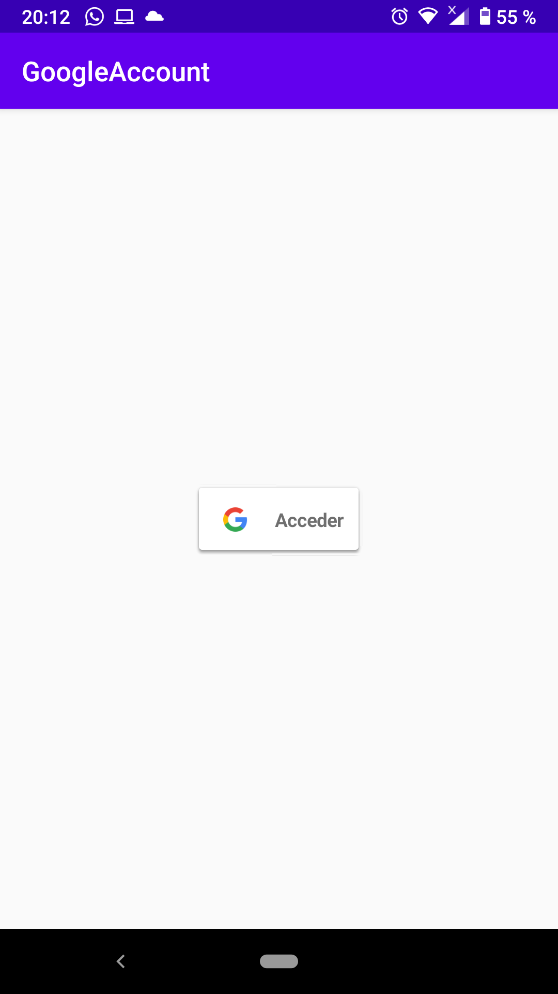 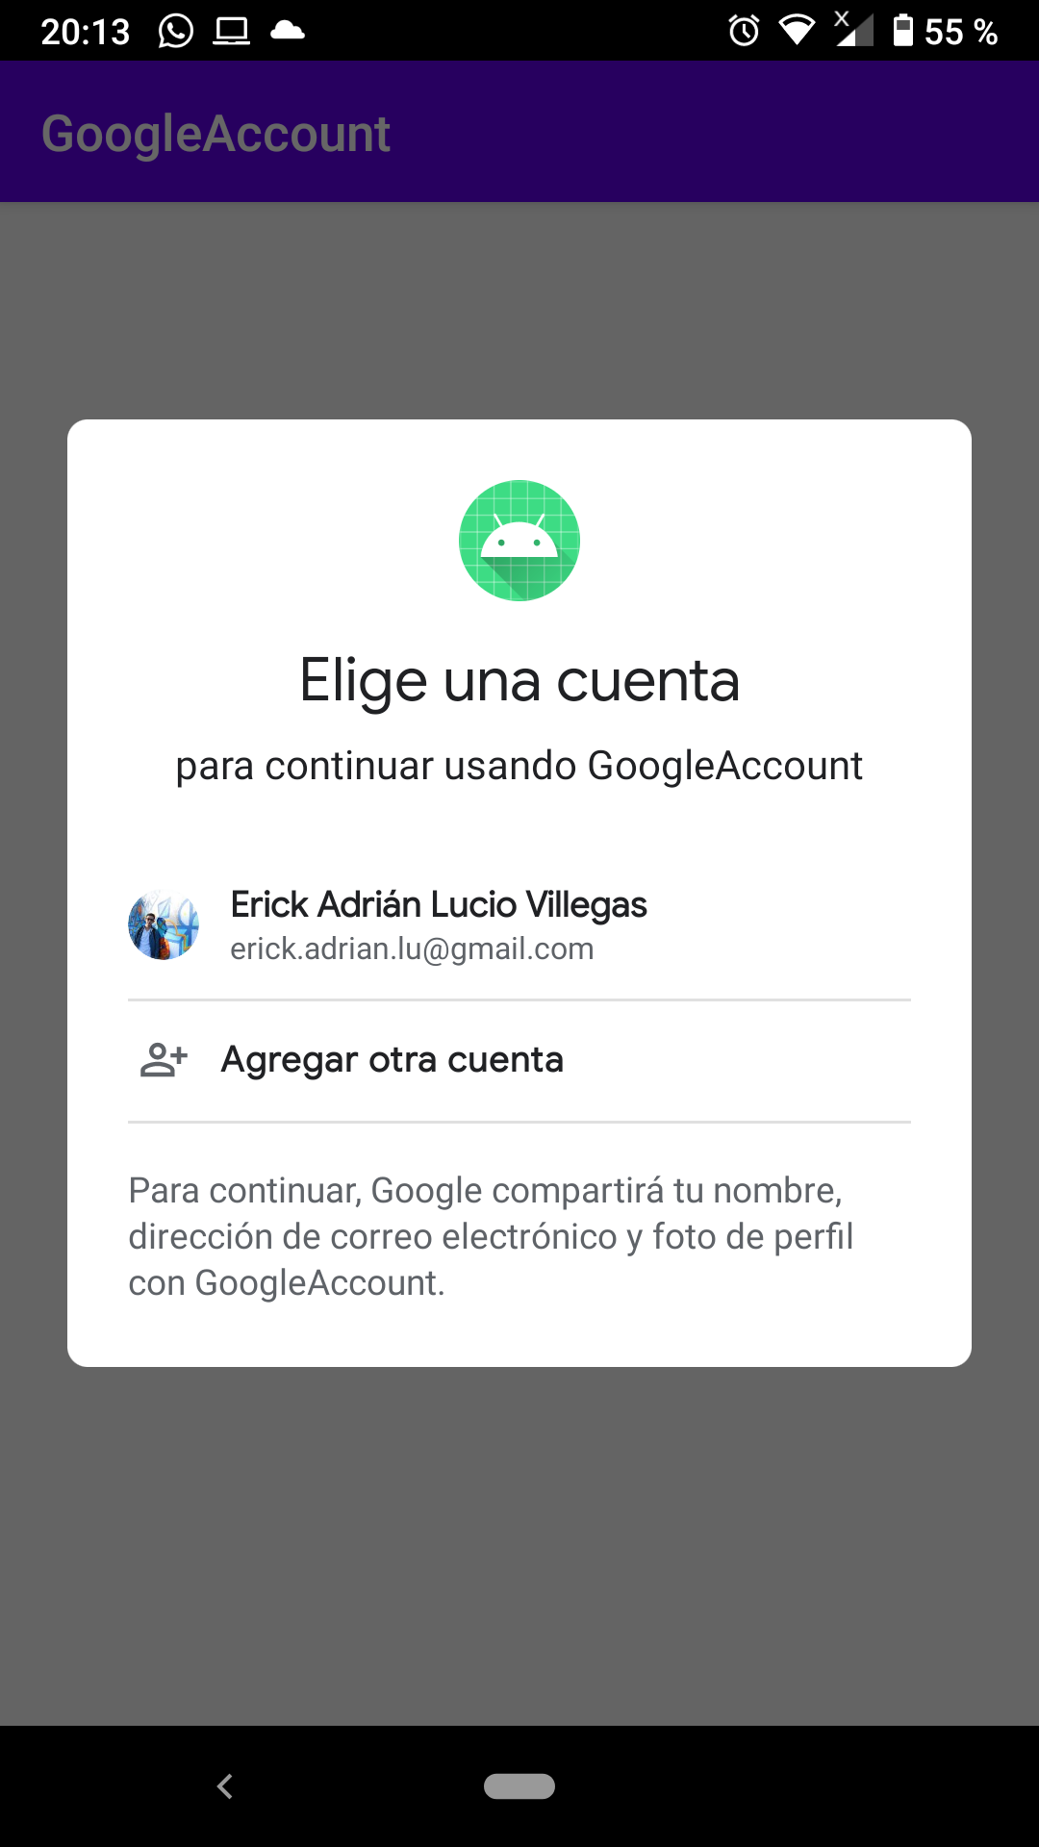

XML

Login

<?xml version="1.0" encoding="utf-8"?>  
<androidx.constraintlayout.widget.ConstraintLayout xmlns:android="http://schemas.android.com/apk/res/android"  
 xmlns:app="http://schemas.android.com/apk/res-auto"  
 xmlns:tools="http://schemas.android.com/tools"  
 android:layout_width="match_parent"  
 android:layout_height="match_parent"  
 tools:context=".MainActivity">  
  
 <FrameLayout  
 android:layout_width="match_parent"  
 android:layout_height="match_parent"  
 app:layout_constraintEnd_toEndOf="parent"  
 tools:context=".MainActivity">  
  
 <com.google.android.gms.common.SignInButton  
 android:id="@+id/sign_in_button"  
 android:layout_width="284dp"  
 android:layout_height="wrap_content"  
 android:layout_gravity="center" />  
 </FrameLayout>  
  
</androidx.constraintlayout.widget.ConstraintLayout>

Perfil

<?xml version="1.0" encoding="utf-8"?>  
<androidx.constraintlayout.widget.ConstraintLayout xmlns:android="http://schemas.android.com/apk/res/android"  
 xmlns:app="http://schemas.android.com/apk/res-auto"  
 xmlns:tools="http://schemas.android.com/tools"  
 android:layout_width="match_parent"  
 android:layout_height="match_parent"  
 tools:context=".MainActivity">  
  
 <FrameLayout  
 android:layout_width="match_parent"  
 android:layout_height="match_parent"  
 app:layout_constraintEnd_toEndOf="parent"  
 tools:context=".MainActivity">  
  
 <com.google.android.gms.common.SignInButton  
 android:id="@+id/sign_in_button"  
 android:layout_width="284dp"  
 android:layout_height="wrap_content"  
 android:layout_gravity="center" />  
 </FrameLayout>  
  
</androidx.constraintlayout.widget.ConstraintLayout>

<?xml version="1.0" encoding="utf-8"?>  
<androidx.constraintlayout.widget.ConstraintLayout xmlns:android="http://schemas.android.com/apk/res/android"  
 xmlns:app="http://schemas.android.com/apk/res-auto"  
 xmlns:tools="http://schemas.android.com/tools"  
 android:layout_width="match_parent"  
 android:layout_height="match_parent"  
 tools:context=".ProfileActivity">  
 <RelativeLayout xmlns:android="http://schemas.android.com/apk/res/android"  
 android:layout_width="match_parent"  
 android:layout_height="match_parent"  
 tools:context="example.javatpoint.com.firebasegooglelogin.ProfileActivity">  
  
 <LinearLayout  
 android:layout_width="match_parent"  
 android:layout_height="match_parent"  
 android:gravity="center"  
 android:orientation="vertical">  
  
 <ImageView  
 android:layout_width="80dp"  
 android:layout_height="80dp"  
 android:id="@+id/profileImage"  
 />  
  
 <TextView  
 android:layout_width="wrap_content"  
 android:layout_height="wrap_content"  
 android:id="@+id/name"  
 android:text="name"  
 android:textSize="20dp"  
 android:layout_marginTop="20dp"/>  
 <TextView  
 android:layout_width="wrap_content"  
 android:layout_height="wrap_content"  
 android:id="@+id/email"  
 android:textSize="20dp"  
 android:text="email"  
 android:layout_marginTop="20dp"/>  
 <TextView  
 android:layout_width="wrap_content"  
 android:layout_height="wrap_content"  
 android:id="@+id/userId"  
 android:textSize="20dp"  
 android:text="id"  
 android:layout_marginTop="20dp"/>  
 <Button  
 android:layout_width="wrap_content"  
 android:layout_height="wrap_content"  
 android:id="@+id/logoutBtn"  
 android:text="Logout"  
 android:layout_marginTop="30dp"/>  
 </LinearLayout>  
 </RelativeLayout>  
  
</androidx.constraintlayout.widget.ConstraintLayout>

MainActivity

package com.example.loginact;  
  
import androidx.appcompat.app.AppCompatActivity;  
import android.os.Bundle;  
import android.util.Log;  
import com.google.android.gms.common.SignInButton;  
import com.google.android.gms.common.api.GoogleApiClient;  
import com.google.firebase.auth.FirebaseAuth;  
import com.google.firebase.auth.FirebaseUser;  
import android.content.Intent;  
import android.view.View;  
import android.widget.Toast;  
import com.google.android.gms.auth.api.Auth;  
import com.google.android.gms.auth.api.signin.GoogleSignInAccount;  
import com.google.android.gms.auth.api.signin.GoogleSignInOptions;  
import com.google.android.gms.auth.api.signin.GoogleSignInResult;  
import com.google.android.gms.tasks.OnCompleteListener;  
import com.google.android.gms.tasks.Task;  
import com.google.firebase.auth.AuthCredential;  
import com.google.firebase.auth.AuthResult;  
import com.google.firebase.auth.GoogleAuthProvider;  
import androidx.annotation.NonNull;  
  
public class MainActivity extends AppCompatActivity {  
 private static final String *TAG* = "MainActivity";  
 private SignInButton signInButton;  
 private GoogleApiClient googleApiClient;  
 private static final int *RC_SIGN_IN* = 1;  
 String name, email;  
 String idToken;  
 private FirebaseAuth firebaseAuth;  
 private FirebaseAuth.AuthStateListener authStateListener;  
  
 @Override  
 protected void onCreate(Bundle savedInstanceState) {  
 super.onCreate(savedInstanceState);  
 setContentView(R.layout.*activity_main*);  
 firebaseAuth = com.google.firebase.auth.FirebaseAuth.*getInstance*();  
 //this is where we start the Auth state Listener to listen for whether the user is signed in or not  
 authStateListener = new FirebaseAuth.AuthStateListener() {  
 @Override  
 public void onAuthStateChanged(@NonNull FirebaseAuth firebaseAuth) {  
 // Get signedIn user  
 FirebaseUser user = firebaseAuth.getCurrentUser();  
  
 //if user is signed in, we call a helper method to save the user details to Firebase  
 if (user != null) {  
 // User is signed in  
 // you could place other firebase code  
 //logic to save the user details to Firebase  
 Log.*d*(*TAG*, "onAuthStateChanged:signed_in:" + user.getUid());  
 } else {  
 // User is signed out  
 Log.*d*(*TAG*, "onAuthStateChanged:signed_out");  
 }  
 }  
 };  
 //  
 GoogleSignInOptions gso = new GoogleSignInOptions.Builder(GoogleSignInOptions.*DEFAULT_SIGN_IN*)  
 .requestIdToken(getString(R.string.*web_client_id*))//you can also use R.string.default_web_client_id  
 .requestEmail()  
 .build();  
 GoogleApiClient client = new GoogleApiClient.Builder(this)  
 .enableAutoManage(this, (GoogleApiClient.OnConnectionFailedListener) this)  
 .addApi(Auth.*GOOGLE_SIGN_IN_API*,gso)  
 .build();  
  
 signInButton = findViewById(R.id.*sign_in_button*);  
 signInButton.setOnClickListener(new View.OnClickListener() {  
 @Override  
 public void onClick(View view) {  
 Intent intent = Auth.*GoogleSignInApi*.getSignInIntent(googleApiClient);  
 startActivityForResult(intent,*RC_SIGN_IN*);  
 }  
 });  
 }  
 @Override  
 protected void onActivityResult(int requestCode, int resultCode, Intent data) {  
 super.onActivityResult(requestCode, resultCode, data);  
 if(requestCode==*RC_SIGN_IN*){  
 GoogleSignInResult result = Auth.*GoogleSignInApi*.getSignInResultFromIntent(data);  
 handleSignInResult(result);  
 }  
 }  
 private void handleSignInResult(GoogleSignInResult result){  
 if(result.isSuccess()){  
 GoogleSignInAccount account = result.getSignInAccount();  
 idToken = account.getIdToken();  
 name = account.getDisplayName();  
 email = account.getEmail();  
 // you can store user data to SharedPreference  
 AuthCredential credential = GoogleAuthProvider.*getCredential*(idToken, null);  
 firebaseAuthWithGoogle(credential);  
 }  
 else{  
 // Google Sign In failed, update UI appropriately  
 Log.*e*(*TAG*, "Login Unsuccessful. "+result);  
 Toast.*makeText*(this, "Login Unsuccessful", Toast.*LENGTH_SHORT*).show();  
 }  
 }  
 private void firebaseAuthWithGoogle(AuthCredential credential){  
 firebaseAuth.signInWithCredential(credential)  
 .addOnCompleteListener(this, new OnCompleteListener<AuthResult>() {  
 @Override  
 public void onComplete(@NonNull Task<AuthResult> task) {  
 Log.*d*(*TAG*, "signInWithCredential:onComplete:" + task.isSuccessful());  
 if(task.isSuccessful()){  
 Toast.*makeText*(MainActivity.this, "Login successful", Toast.*LENGTH_SHORT*).show();  
 gotoProfile();  
 }else{  
 Log.*w*(*TAG*, "signInWithCredential" + task.getException().getMessage());  
 task.getException().printStackTrace();  
 Toast.*makeText*(MainActivity.this, "Authentication failed.",  
 Toast.*LENGTH_SHORT*).show();  
 }  
  
 }  
 });  
 }  
 private void gotoProfile(){  
 Intent intent = new Intent(MainActivity.this, ProfileActivity.class);  
 intent.setFlags(Intent.*FLAG_ACTIVITY_NEW_TASK* | Intent.*FLAG_ACTIVITY_CLEAR_TASK*);  
 startActivity(intent);  
 finish();  
 }  
 @Override  
 protected void onStart() {  
 super.onStart();  
 if (authStateListener != null){  
 FirebaseAuth.*getInstance*().signOut();  
 }  
 firebaseAuth.addAuthStateListener(authStateListener);  
 }  
  
 @Override  
 protected void onStop() {  
 super.onStop();  
 if (authStateListener != null){  
 firebaseAuth.removeAuthStateListener(authStateListener);  
 }  
 }  
  
}

}

ProfileActivity

package com.example.loginact;

import androidx.annotation.NonNull;  
import androidx.appcompat.app.AppCompatActivity;  
import android.content.Intent;  
import android.os.Bundle;  
import android.view.View;  
import android.widget.Button;  
import android.widget.ImageView;  
import android.widget.TextView;  
import android.widget.Toast;  
  
import com.bumptech.glide.Glide;  
import com.google.android.gms.auth.api.Auth;  
import com.google.android.gms.auth.api.signin.GoogleSignInAccount;  
import com.google.android.gms.auth.api.signin.GoogleSignInOptions;  
import com.google.android.gms.auth.api.signin.GoogleSignInResult;  
import com.google.android.gms.common.ConnectionResult;  
import com.google.android.gms.common.api.GoogleApiClient;  
import com.google.android.gms.common.api.OptionalPendingResult;  
import com.google.android.gms.common.api.ResultCallback;  
import com.google.android.gms.common.api.Status;  
import com.google.firebase.auth.FirebaseAuth;  
  
  
  
public class ProfileActivity extends AppCompatActivity {  
 Button logoutBtn;  
 TextView userName,userEmail,userId;  
 ImageView profileImage;  
 private GoogleApiClient googleApiClient;  
 private GoogleSignInOptions gso;  
  
 @Override  
 protected void onCreate(Bundle savedInstanceState) {  
 super.onCreate(savedInstanceState);  
 setContentView(R.layout.*activity_profile*);  
 logoutBtn = findViewById(R.id.*logoutBtn*);  
 userName = findViewById(R.id.*name*);  
 userEmail = findViewById(R.id.*email*);  
 userId = findViewById(R.id.*userId*);  
 profileImage = findViewById(R.id.*profileImage*);  
  
 gso = new GoogleSignInOptions.Builder(GoogleSignInOptions.*DEFAULT_SIGN_IN*)  
 .requestEmail()  
 .build();  
  
 googleApiClient=new GoogleApiClient.Builder(this)  
 .enableAutoManage(this, (GoogleApiClient.OnConnectionFailedListener) this)  
 .addApi(Auth.*GOOGLE_SIGN_IN_API*,gso)  
 .build();  
  
 logoutBtn.setOnClickListener(new View.OnClickListener() {  
 @Override  
 public void onClick(View view) {  
 FirebaseAuth.*getInstance*().signOut();  
 Auth.*GoogleSignInApi*.signOut(googleApiClient).setResultCallback(  
 new ResultCallback<Status>() {  
 @Override  
 public void onResult(Status status) {  
 if (status.isSuccess()){  
 gotoMainActivity();  
 }else{  
 Toast.*makeText*(getApplicationContext(),"Session not close",Toast.*LENGTH_LONG*).show();  
 }  
 }  
 });  
 }  
 });  
 }  
  
 @Override  
 protected void onStart() {  
 super.onStart();  
 OptionalPendingResult<GoogleSignInResult> opr= Auth.*GoogleSignInApi*.silentSignIn(googleApiClient);  
 if(opr.isDone()){  
 GoogleSignInResult result=opr.get();  
 handleSignInResult(result);  
 }else{  
 opr.setResultCallback(new ResultCallback<GoogleSignInResult>() {  
 @Override  
 public void onResult(@NonNull GoogleSignInResult googleSignInResult) {  
 handleSignInResult(googleSignInResult);  
 }  
 });  
 }  
 }  
  
 private void handleSignInResult(GoogleSignInResult result){  
 if(result.isSuccess()){  
 GoogleSignInAccount account=result.getSignInAccount();  
 userName.setText(account.getDisplayName());  
 userEmail.setText(account.getEmail());  
 userId.setText(account.getId());  
 try{  
 Glide.*with*(this).load(account.getPhotoUrl()).into(profileImage);  
 }  
 catch (NullPointerException e){  
 Toast.*makeText*(getApplicationContext(),"image not found",Toast.*LENGTH_LONG*).show();  
 }  
  
 }else{  
 gotoMainActivity();  
 }  
 }  
  
 private void gotoMainActivity(){  
 Intent intent=new Intent(this,MainActivity.class);  
 startActivity(intent);  
 }  
  
  
}